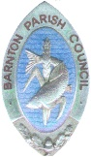
Barnton Parish Council
MINUTES FROM THE FINANCE/GP COMMITTEE MEETING
Barnton Parish Council
Held on; Tuesday 25th January 2022 at 6.30pm at Christ Church, Barnton

ATTENDED BY; | - Cllr Hooper, Chairperson  - Cllr Hughes
Min. Ref; | Item
FGP1/10/21 | To receive apologies for absence  Cllr Divine, Cllr Mayers  This meeting was cancelled due to being inquorate

